MSDS 6371 ANALYSIS QUESTION: Summer 2025 Midterm Exam
HONOR CODE: By taking this test and typing your name below, you are:
- …agreeing on your honor and in accordance with the SMU Honor Code (but more importantly, on your honor) to not have communicated with anyone, during the exam, in this class or outside of this class, that could have helped obtain answers to these questions. “Communicated” means by any medium including talking, phone, Slack, Discord, email, text, Facetime, Instagram, snap chat, etc. You are also agreeing
- … no text was copied or pasted from sources other than your own.
Please type your name here which serves as your signature ________________________________________
Directions and Submission: Simply save your answers to this document and upload them to the Final Exam assignment on 2DS with your name in the file name. You should type your answers directly into this document. You may do any mathematical work by hand and include a picture of that work in this document or simply type those calculations into this document.
Unless otherwise specified, assume $α=0.05$ and 95% confidence.
- (1 pts each)Complete the table with the appropriate symbol or description:
Symbol | Description
$$\overline{x}$$
 | Sample variance
$$σ^{2}$$
 | Sample standard deviation
$$μ$$
 | Sample Size

- Who said, “All models are wrong but some are useful?” (2 pts)

- We conducted an experiment in which we had 4 groups (1,2,3 and 4) and we had 5 observations per group. A plot of the data is below along with the assumed normal distributions of the responses per group. Note, we are also assuming that the variance is the same for each normal distribution. An ANOVA was run and some of the results are in the table below the plot.
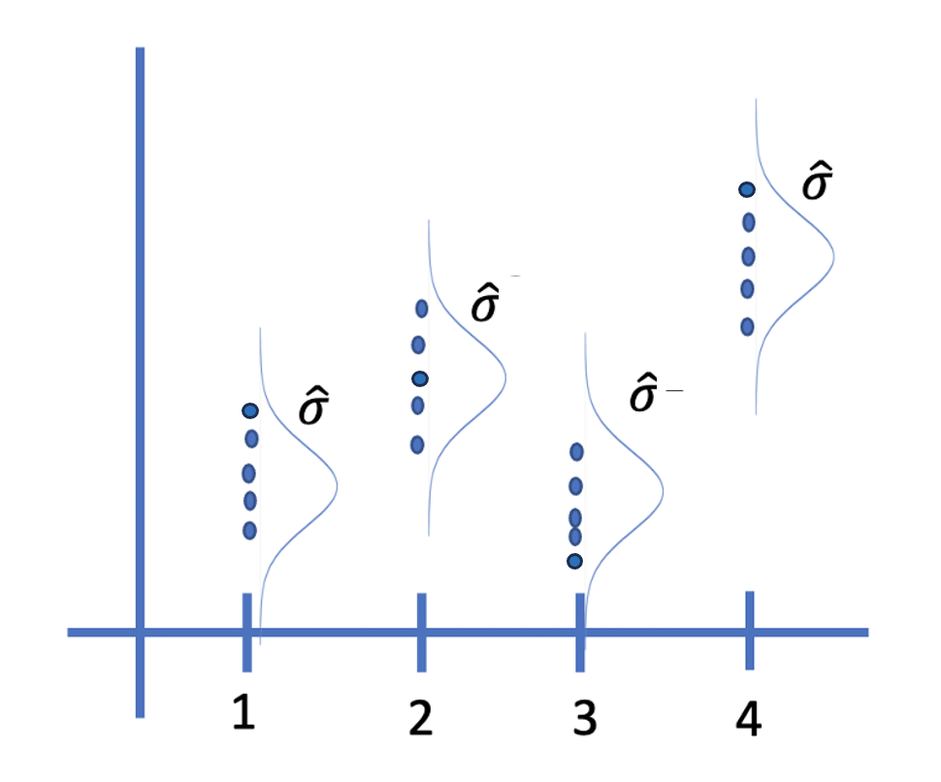
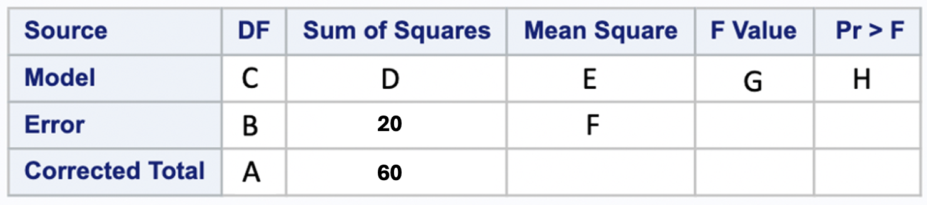
Indicate the corresponding values referenced above in the table and plot as well as the MSE, R², $\hat{σ}$ and the estimate of the pooled standard deviation (1 pt each):
A:
B:
C:
D:
E:
F:
G:
H:
MSE:
R²:
$\hat{σ}$:
What is the estimate of the pooled standard deviation:

- Matching (1 pt each) Letters can be used more than once!
Assume we are testing the claim that the mean heart beats per minute (bpm) of males is 9$3 bpm$.
$$H_{o}: μ=93bpm$$
$$H_{a}: μ≠93bpm$$
- Rejecting Ho when the true mean bpm is 93bpm. ___

- The probability of failing to reject Ho when the true mean bpm is 9$7$ . ___

- When the effect size goes from 10bpm to 5bpm, what happens to the power? _______

- When the significance level (alpha) goes from .05 to .01 what happens to the power? _______

- Failing to Reject Ho when the true mean bpm is $87$. ___

- The probability of rejecting Ho when the true bpm is $87$ . ___

a. Type 1 Error  b. Type 2 Error  c. R² | d. degrees of freedom  e. $\hat{y}$  f. Power | g. $α$  h. $β$  i. Extrapolation | j. pvalue  k. proportion  l. residual | m. increases  n. decreases

- Ho:$μ=90$
Ha:$μ≠90$
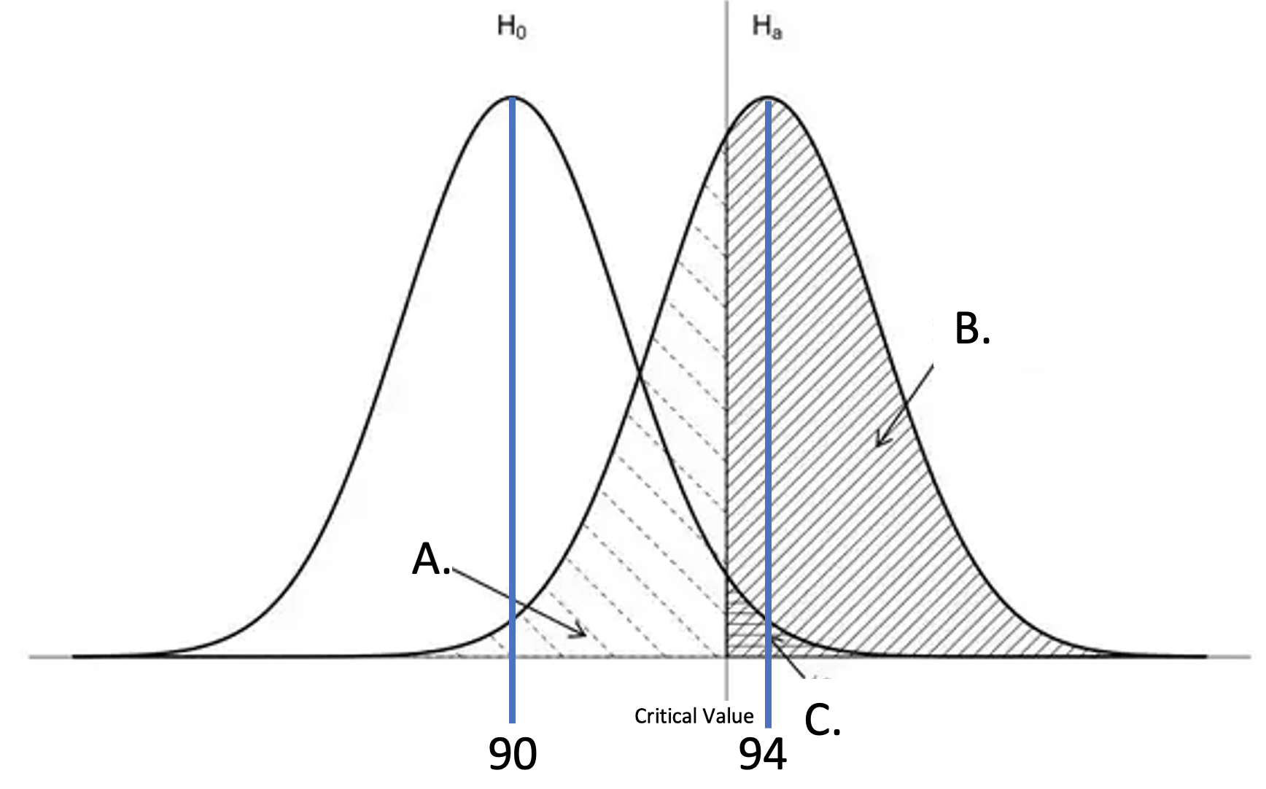
Consider the Ho, Ha and drawing above. Answer a, b and c below from the answer bank in question 4 and answer d with a number. (2 pts each)

- What does A represent?
- What does B represent?
- What does C represent?
- What is the effect size?

MSDS 6371 ANALYSIS QUESTION: Summer 2025 (55 pts)
In the past 20 years, scientists have discovered that plastic has become an increasing threat to wildlife in the ocean. It is also thought that with Asia’s rapid growth that there may be more pollution coming from Asia than from the Americas. In order to test this hypothesis, 53 boats were deployed in the West Pacific Ocean and 54 boats were deployed in the East Pacific in order to measure the level of plastic in each region (in ounces). Each boat collected all the plastic present on the surface of the water in a square kilometer at a particular time of the day (or night). The weight of this plastic was recorded in ounces and can be found in the data file provided: plasticEastWest2025.csv.
Interestingly, there is a form of bacteria that is thought to be evolving to actually eat plastic and use it as a source of nutrition. The level of this bacteria in each square kilometer plot (Ideonella sakainesis) was also recorded by each boat recorded in bacterial per milliliter (bpml).
In addition to the plastic and Ideonella sakainesis level in each square kilometer plot, the water temperature of each square kilometer was recorded by each boat as well. Finally, you may assume that the square kilometer “plots” were far enough away from each other that they can be considered independent observations.
For all problems below assume an alpha = .05 level of significance and 95% confidence intervals. Also, you do not need to draw and shade for step 2 of a hypothesis test for these questions. Additionally, please provide confidence intervals when appropriate and possible.
Please put all code either in your response to the problem or in an appendix at the end of the test.
- (25 pts) Conduct a two-sample t-test to test the claim that the mean plastic level (in ounces) is greater in the West Pacific than in the East. You may assume the assumptions are met for this test. For the actual test, please provide the six-step test with a confidence interval and scope of inference that addresses causality (if the result is significant) and the generalizability of the result. In addition, in conducting this test, you are assuming that the standard deviation of the plastic levels in the East and West Pacific are equal. Provide the estimate of this standard deviation. We of course need the most powerful and most appropriate analysis.
- (10 pts) The researcher would now like to investigate if there are differences in mean or median bacteria levels based on the time of day and, if so, they would like to quantify / describe those specific differences. You may assume the assumptions of any tests you run are met for the test(s) you choose. We of course need the most powerful and most appropriate analysis.
- (25 pts) Near the end of the experiment the researchers decided to perform one last study. One researcher had a thought that an experimental enzyme they had been working with might help dissolve plastic in the ocean into inert subcomponents. They didn’t have much time or enzyme so they selected 8 “plots” in the ocean to conduct the experiment. For each plot, the researchers remeasured the plastic in the plot and then applied the enzyme to the water in that plot. They waited 2 hours and then came back to the plot and remeasured the plastic in the plot. The data are recorded in BacteriaEnzymeStudy.csv. Conduct the appropriate test and make sure to provide a clear conclusion as to if there is evidence to suggest that the enzyme is effective in reducing plastic in the ocean. Please address the assumptions of any methods / tests you use in your response / analysis. We of course need the most powerful and most appropriate analysis.

